Project Description

Contents

Overview 2

Team 2

Director 2

Designer Lead 2

Research & Development Lead 2

Design & Programming 2

Fire & Safety Lead 2

Learning Objectives 3

Target Audience 4

Simulation Overview 4

Player Interaction in Room 4

Player Interaction in Hallway 4

Player Interaction in Stairs 5

Player Interaction in Outside 5

Player Interaction with Smoke 6

Player Interaction with Fire 6

Graphic User Interfaces 6

Player GUI 6

Game Master GUI 6

Development Calendar 6

Budget 6

Administration of the system 6

Where does the system lives 6

Who maintain the system 6

What is the 5-year sustenance plan 6

Marketing 6

Glossary 6

# Overview

The Fire Escape Learning Instrument eXperiment (FELIX) is a project developed by Technology Across the Curriculum (TAC) at Oregon State University (OSU). FELIX is a Virtual Learning Environment in which a student is faced with a realistic third-person simulation of a fire in the dormitory. The goal of the simulation is to allow the student to practice good behaviors during an evacuation. FELIX also provide tools for the instructor to monitor the student during the simulation, as well as manipulate the environment and change the simulation on the go. In absence of an instructor, the environment adapts automatically to the learner using scenarios and Artificial Intelligence (AI). The AI learns to recognize the different mental states of the student, and adapt the pedagogy of the simulation according, to maximize learning outcomes. Finally, FELIX allows for a group learning experience, with up to 4 students in the simulation at the same time, from remote locations.

# Team

## Director

Jon Dorbolo, [jon.dorbolo@oregonstate.edu](mailto:jon.dorbolo@oregonstate.edu), 541 737 3811

## Designer Lead

Kimmy Hescock, [Kimmy.hescock@oregonstate.edu](mailto:Kimmy.hescock@oregonstate.edu)

## Research & Development Lead

Béatrice Moissinac, [Beatrice.moissinac@oregonstate.edu](mailto:Beatrice.moissinac@oregonstate.edu)

## Design & Programming

Justin Bruntmyer

Jianqing Cui

Andrea McFarland

Rob Rodger

Nan Shi

Christopher Tucker

## Fire & Safety Lead

Jim Patton

Michael Bamberger

# Learning Objectives

The learning objectives are a set of proper behavior to have during the evacuation of a building on fire.

|  |  |  |
| --- | --- | --- |
| **Skill Name** | **Skill Code** | **Description of skill** |
| Hear alarm | ALR | When hearing the fire alarm, attempt to evacuate the building without delay, via the most direct and safe route |
| Call 9-1-1 | CL_p (possible)  CL_s (safe) | Call 9-1-1 as soon as possible and safe |
| Smoke | SM1 | If there is smoke up high and you can see below the smoke, you should crawl on your hands and knees to the nearest exit. |
|  | SM2 | If there is smoke from ceiling to floor, find another way out, or stay put in your room |
| Room | RM1 | If you have to stay put in your room, seal the cracks around your door, call 9-1-1 to report your situation, hang a bright colored sheet from your window and wait by the window to be rescued. |
| Open Door | DR1 | If door is warm or hot, do not open the door. |
|  | DR2 | If door is neither warm nor hot, open slowly to check the other side. |
| Elevator | EL1 | Never take an elevator, always use the nearest stairs. |
| Out of building | OUT1 | Once out of the building, evacuate to your predetermine assembly point |
|  | OUT2 | One out of the building, evacuate to at least 50 feet away from the building. Out of the way of emergency vehicles. |
| Distraction | DT1 | Don’t be distracted, don’t text, don’t answer your phone etc… Don’t take valuables. Don’t wait for anyone. |
| Windows | WD1 | Open window only if you need fresh air for the room |
|  | WD2 | Lowered yourself of a window only in a life-saving effort from 2nd floor or below |
| Building | BL1 | Get away from the building at least 50 feet |
|  | BL2 | Get to your designated evacuation area |
| Touch Door | TD1 | Touch door with back of hand to judge temperature of door. |
| Wait | WT1 | Wait to be rescued by EMT |

# Target Audience

Oregon State University students, faculty, and staff using campus during day-time, or living on campus.

# Simulation Overview

The simulation has a linear story presented in Figure 1. Each square in Figure 1 is called a **state.** A state defines is a standardized part of the environment, presenting a physical separation with other states (e.g. room, hallway, staircase). Each state possess its own set of skills and assets.

The student can start at any point on the diagram, and the goal is to rally the assembly point outside. FELIX can generate an infinity of layouts following this basic scheme.

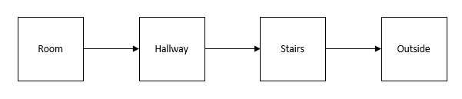

Figure 1- Flow chart of states

## Player Interaction in Room

## Player Interaction in Hallway

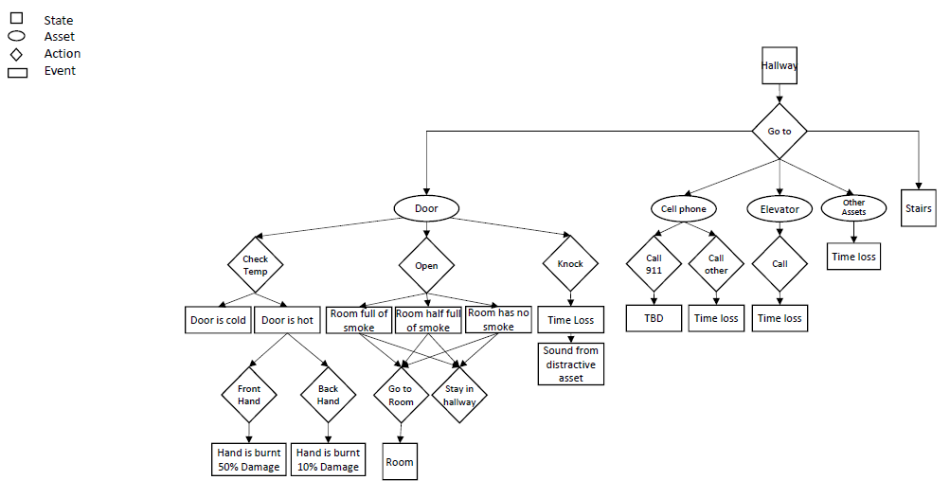

## Player Interaction in Stairs

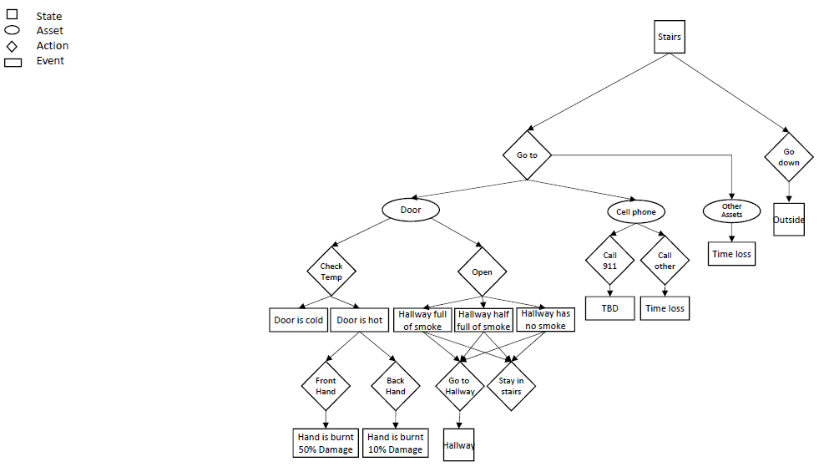

## Player Interaction in Outside

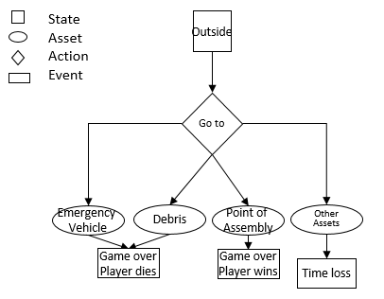

## Player Interaction with Smoke

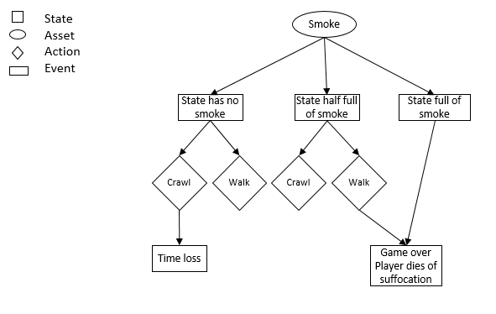

## Player Interaction with Fire

To be done

# Graphic User Interfaces

## Player GUI

To be done

## Game Master GUI

To be done

# Development Calendar

# Budget

# Administration of the system

## Where does the system lives

## Who maintain the system

## What is the 5-year sustenance plan

# Marketing

# Glossary

|  |  |
| --- | --- |
| Action | An action is what the player or game master do. The actions are prompted via the Action Menu |
| AI | Artificial Intelligence, not to be confused with pre-programmed scenarii, is the algorithm that learns to react to the player’s actions and decide on the next event. |
| Asset | Tangible object modeled in the simulation (i.e. table, bed, chair, door, car etc...) |
| Avatar | Representation of the player’s body in the simulation |
| Event | A thing that happens in the simulation. It may be a consequence of a previous event, an action from the player or the game master. Some events can directly affect the player. |
| Event Map |  |
| Fire | “The”  Fire |
| Game Master | AI or person having the controls over the simulation |
| Interactable Asset | Asset that allows interaction with the player |
| Interaction  Map | Diagram mapping the interactable assets to their actions availables to the player in each state.It also maps the consequences of actions on the environment, as event. |
| Non-interactable Asset | Asset that does not allow interaction with the player |
| Player | A player is a participant. We refer to them interchangeably. |
| Participant | A participant is a player. We refer to them interchangeably. |
| State | Standardized environment part of the simulation, presenting a physical separation with other states (e.g. room, hallway, fire escape, outside, staircase) |